THEORY QUESTIONS
1.
Study Figure 1 carefully and use it to answer questions (a) to (e).
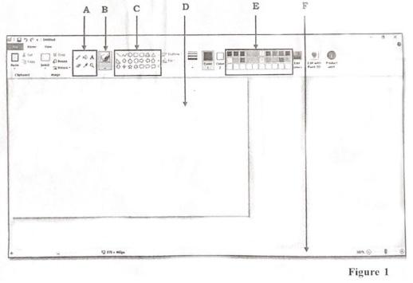
a)

Write the name of the application displayed in Figure 1
b)

Mention two things that the application identified in Figure 1 can be used to create.
c)

Write the name of the parts labelled A, B, C, D, E and F in Figure 1
d)

List two of items found in the part labelled A
e)

What is the part labelled D used for?

2.
a)

State two reasons for copyright protection.
b)

List four products that normally requires copyright protection.
c)

Outline the steps involved in restoring a deleted file.

3.
a)

Write the following acronyms in full:
i)

CD
ii)

CPU
iii)

DVD
b)

Explain the following terminologies as used in computing.
i)

Data
ii)

Computer

4.
State the steps involved in performing the following operations:
a)

Saving a newly created document in word processing application using the appropriate menu command.
b)

Cutting and pasting a word document from one folder into another folder all on the desktop.

5.
State the function of each of the following e-mails terminologies.
a)

To: .......................
b)

Subject: ...................
c)

Carbon Copy (CC): .....................
d)

Blind Carbon Copy (BCC): ...................

